## DDL Commands

CREATE TABLE DOCTOR(

doc_id INT NOT NULL,

doc_name VARCHAR(30) NOT NULL,

speciality VARCHAR(40) NOT NULL,

)

alter table DOCTOR

add constraint PK_docID primary key(doc_id);

CREATE TABLE PATIENT(

patient_id INT NOT NULL,

p_fname VARCHAR(15) NOT NULL,

p_mname VARCHAR(15) NOT NULL,

p_lname VARCHAR(15) NOT NULL ,

gender VARCHAR(1) NOT NULL ,

p_address TEXT ,

number nvarchar(100) not null,

CONSTRAINT CHK_gender CHECK(gender in ('M', 'F','O'))

)

alter table PATIENT

add constraint PK_patientID primary key(patient_id);

CREATE TABLE PHARMACY(

ph_id INT NOT NULL ,

ph_name VARCHAR(20) NOT NULL ,

ph_address TEXT ,

)

alter table PHARMACY

add constraint PK_phID primary key(ph_id);

CREATE TABLE EMPLOYEE(

eid INT NOT NULL ,

ph_id INT NOT NULL ,

ename VARCHAR(30) NOT NULL,

contact nvarchar(100) not null,

salary MONEY ,

shift_strt TIME ,

shift_end TIME

)

alter table EMPLOYEE

add constraint PK_eID primary key(eid);

alter table EMPLOYEE

add constraint FK_phID foreign key(ph_id) REFERENCES PHARMACY(ph_id);

CREATE TABLE DRUG(

trade_name VARCHAR(30) NOT NULL ,

content TEXT ,

exp_date DATE

)

alter table DRUG

add constraint PK_tradeNAME primary key(trade_name);

CREATE TABLE PRESCRIPTION(

doc_id INT NOT NULL ,

patient_id INT NOT NULL ,

prescription_date DATE NOT NULL ,

trade_name VARCHAR(30) NOT NULL ,

qty INT

)

alter table PRESCRIPTION

add constraint FK_patientID foreign key(patient_id) REFERENCES PATIENT(patient_id);

alter table PRESCRIPTION

add constraint FK_docID foreign key(doc_id) REFERENCES DOCTOR(doc_id);

alter table PRESCRIPTION

add constraint FK_tradeNAME foreign key(trade_name) REFERENCES DRUG(trade_name);

alter table PRESCRIPTION

add constraint PK_eachPRESCRIPTION primary key(doc_id,patient_id,prescription_date);

CREATE TABLE BUYS(

patient_id INT NOT NULL,

trade_name VARCHAR(30) NOT NULL ,

buy_date DATE NOT NULL ,

qty INT NOT NULL,

price MONEY ,

bill MONEY

)

alter table BUYS

add constraint FK_patientID_buys foreign key(patient_id) REFERENCES PATIENT(patient_id);

alter table BUYS

add constraint FK_tradeNAME_buys foreign key(trade_name) REFERENCES DRUG(trade_name);

alter table BUYS

add constraint PK_eachBUY primary key(patient_id,trade_name,buy_date);

CREATE TABLE COMPANY(

c_id INT NOT NULL,

cname VARCHAR(30) NOT NULL,

c_address TEXT

)

alter table COMPANY

add constraint PK_cID PRIMARY KEY(c_id);

create table MAKES(

c_id INT NOT NULL ,

trade_name VARCHAR(30) NOT NULL

)

ALTER TABLE MAKES

ADD CONSTRAINT FK_cID FOREIGN KEY (c_id) REFERENCES COMPANY (c_id);

ALTER TABLE MAKES

ADD CONSTRAINT FK_tradename_makes FOREIGN KEY (trade_name) REFERENCES DRUG (trade_name);

alter table makes

add constraint PK_eachPRODUCTION PRIMARY KEY (c_id,trade_name)

create table ORDERS(

ph_id INT NOT NULL,

c_id INT NOT NULL ,

trade_name VARCHAR(30) NOT NULL,

o_date DATE NOT NULL,

qty INT NOT NULL,

price MONEY NOT NULL,

bill MONEY NOT NULL,

)

ALTER TABLE ORDERS

ADD CONSTRAINT FK_phID_orders FOREIGN KEY(ph_id) REFERENCES PHARMACY(ph_id)

ALTER TABLE ORDERS

ADD CONSTRAINT FK_cID_orders FOREIGN KEY(c_id) REFERENCES COMPANY(c_id)

ALTER TABLE ORDERS

ADD CONSTRAINT FK_tradename_orders FOREIGN KEY(trade_name) REFERENCES DRUG(trade_name)

ALTER TABLE ORDERS

ADD CONSTRAINT PK_eachORDER PRIMARY KEY(ph_id,c_id,trade_name,o_date)

create table SELLS(

ph_id INT NOT NULL,

trade_name VARCHAR(30) NOT NULL,

qty INT NOT NULL,

price MONEY NOT NULL,

)

ALTER TABLE SELLS

ADD CONSTRAINT FK_phID_sells FOREIGN KEY(ph_id) REFERENCES PHARMACY(ph_id);

ALTER TABLE SELLS

ADD CONSTRAINT FK_tradename_sells FOREIGN KEY(trade_name) REFERENCES DRUG(trade_name)

ALTER TABLE DRUG

ADD color VARCHAR(15)

CREATE TABLE SOLID(

trade_name VARCHAR(30) NOT NULL ,

solid_type varchar(20) not null ,

shape varchar(15) not null,

power int

)

ALTER TABLE SOLID

ADD CONSTRAINT FK_tradename_solid FOREIGN KEY(trade_name) REFERENCES DRUG(trade_name)

CREATE TABLE SEMISOLID(

trade_name VARCHAR(30) NOT NULL ,

ssolid_type varchar(20) not null ,

greasy varchar(1) ,

absorbtion varchar(1),

CONSTRAINT CHK_greasy CHECK(greasy in ('Y', 'N')),

CONSTRAINT CHK_absorbtion CHECK(absorbtion in ('F', 'M','S'))

)

ALTER TABLE SEMISOLID

ADD CONSTRAINT FK_tradename_ssolid FOREIGN KEY(trade_name) REFERENCES DRUG(trade_name)

CREATE TABLE SYRUP(

trade_name VARCHAR(30) NOT NULL ,

taste varchar(20)

)

ALTER TABLE SYRUP

ADD CONSTRAINT FK_tradename_syrup FOREIGN KEY(trade_name) REFERENCES DRUG(trade_name)

## DML Commands

Insert into doctor values('113','Dr.Shetty','cardiac surgeon');

Insert into doctor values('114','Dr.Joshi','physician');

Insert into doctor values('115','Dr.Rao','allergist');

Insert into patient values('50','Simran','Dilipkumar','Bhojwani','F','AmanTalkies,Unr,421003','9730645555');

Insert into patient values('51','Riya','Kamlesh','Dadlani','F','MahanApt,Unr,421001','9784545115');

Insert into patient values('53','Kunal','Jeet','Bhatia','M','TowerOne,Unr,421005','9738534555');

/*alter pateint table */

alter table patient add age int ;

/*updation*/

update patient set dob='1997-06-05' where patient_id='50'

update patient set age='20' where patient_id='50'

update patient set dob='1997-07-15',age='20' where patient_id='51'

update patient set dob='1997-09-24',age='19' where patient_id='53'

Insert into drug values ('Nimesulide','Sterratiopeptidase','2018-07-14','yellow');

Insert into solid values ('Nimesulide','tablet','round','100');

Insert into drug values ('Ranitidine','Ranitidine hydrochloride','2018-02-21','creamish');

Insert into solid values ('Ranitidine','tablet','round','150');

Insert into drug values ('Ketorolac','Sulfa','2018-02-21','white');

Insert into solid values ('Ketorolac','tablet','round','93');

Insert into solid values ('Ketorolac','tablet','round','314');

/*drop column exp date because it is considered in sells that holds the information of stock

har drug ka exp_date har pharmacy will be different */

alter table drug drop column exp_date;

/*add exp_date column to sells*/

alter table sells add exp_date date

alter table sells add batch varchar(30) not null;

Insert into prescription values('113','50','2017-08-26','Nimesulide','100');

Insert into prescription values('114','53','2017-08-26','Ranitidine','100');

Insert into prescription values('114','51','2017-08-26','Ranitidine','150');

Insert into prescription values('115','50','2017-08-27','Ketorolac','10');

Insert into buys values ('50','Nimesulide','2017-08-26','4','100','400');

Insert into buys values ('53','Ranitidine','2017-08-26','3','90','270');

Insert into buys values ('50','Ranitidine','2017-08-26','4','90','360');

Insert into buys values ('51','Ranitidine','2017-08-26','2','90','180');

insert into pharmacy values ('5812','Shreeram','Chembur,mumbai,2241523');

insert into pharmacy values ('1512','Alpha','M.G.Road,Santacruz,341511');

insert into pharmacy values ('5682','Allright','Saharacity,Delhouse,1753122');

insert into employee values ('1','5812','Ramesh','9545264523','15000','09:00:00','22:00:00');

insert into employee values ('2','5812','Suresh','9545264888','15400','09:00:00','22:00:00');

insert into employee values ('5','5682','Rajesh','9545856943','15600','08:00:00','23:00:00');

insert into employee values ('3','1512','Kamlesh','9545264885','14000','09:30:00','22:00:00');

insert into employee values ('4','1512','Dinesh','9555864523','16500','09:30:00','22:00:00');

/*patient buys drugs from pharmacy to keep record from which pharmacy pateint bought drug*/

alter table buys add ph_id int;

alter table buys add constraint FK_phID_buys foreign key (ph_id) references pharmacy(ph_id);

update buys set ph_id='5812' where patient_id='50';

update buys set ph_id='1512' where patient_id='51';

update buys set ph_id='5682' where patient_id='53';

select * from buys

alter table sells drop constraint PK_stack

ALTER TABLE SELLS

ADD CONSTRAINT PK_stack PRIMARY KEY(ph_id,trade_name,qty,batch)

insert into sells values ('5812','Nimesulide','50','100','2018-08-02','16ba');

insert into sells values ('5812','Ranitidine','50','90','2018-05-02','16ra');

insert into sells values ('1512','Ranitidine','25','90','2018-08-02','16bl');

insert into sells values ('5682','Ranitidine','10','90','2017-09-13','15kg');

insert into prescription values('113','53','2017-08-27','Ketorolac','15');

insert into buys(patient_id,trade_name,buy_date,qty) values('50','Ketorolac','2017-09-27','10');

insert into buys(patient_id,trade_name,buy_date,qty) values('51','Ketorolac','2017-09-27','10');

insert into buys(patient_id,trade_name,buy_date,qty) values('50','Ketorolac','2017-09-27','10');

insert into buys(patient_id,trade_name,buy_date,qty) values('53','Ketorolac','2017-09-27','15');

insert into buys(patient_id,trade_name,buy_date,qty) values('50','Ketorolac','2017-10-27','10');

/**/

alter table orders drop column contractof;

alter table orders add contractof int;

insert into COMPANY values('9999','SBManufactures','ClanColony,Chembur,2241523');

insert into COMPANY values('9998','HighQuality','TechArea,Thane,564821');

insert into COMPANY values('9997','RegalManufactures','IndustrialArea,VileParle,756243');

insert into COMPANY values('9996','HDPharmacuticals','Vashi,125484');

insert into orders values('5812','9996','Nimesulide','2017-08-26','100','4500','450000','2');

insert into orders values('5682','9997','Ketorolac','2016-08-28','500','5600','2800000','2');

insert into orders values('1512','9998','Ranitidine','2015-08-26','100','2300','230000','2');

insert into orders values('5812','9999','Nimesulide','2017-08-26','300','1200','360000','2');

insert into orders values('5682','9996','Ketorolac','2015-09-23','400','2300','920000','2');

insert into orders values('1512','9997','Ranitidine','2016-04-26','200','1000','200000','2');

insert into buys values(53,'Ranitidine','2017-08-12','6','90','540','5682');

insert into drug values('soframycin','Framycetin Sulfate','white');

insert into drug values('borolean','Zinc oxide','white');

insert into drug values('betadine','Dibasic sodium phosphate','white');

insert into semisolid values('soframycin','oinment','Y','F');

insert into semisolid values('borolean','oinment','Y','M');

insert into semisolid values('betadine','oinment','Y','M');

COMPLEX QUERIES

1.

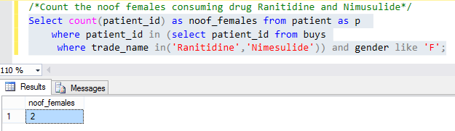

2.

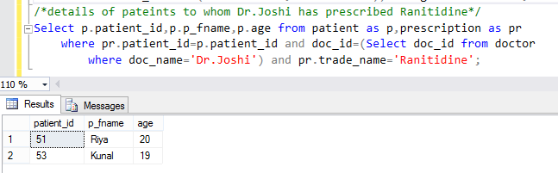

3.

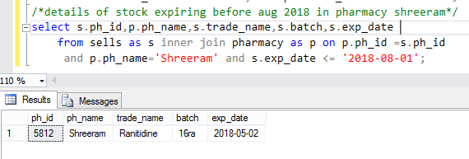

4.

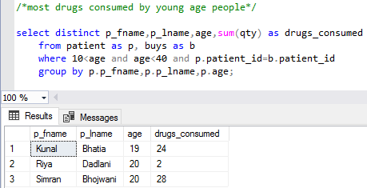

5.

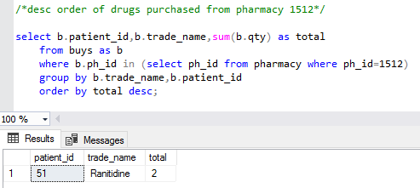

JOIN:

1.

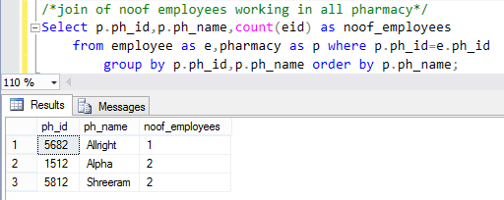

2.

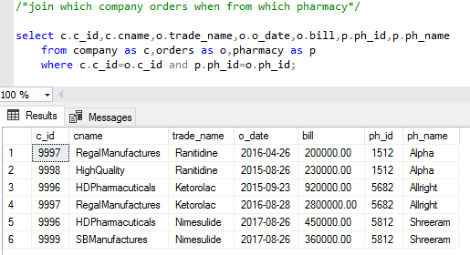

VIEW:

1.

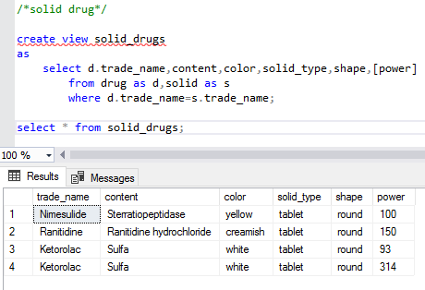

2.

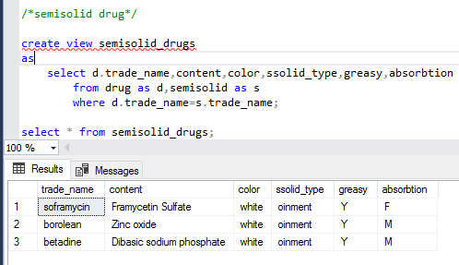

QUERY USING VIEW:

